**Factors that influence the innovativeness of U.S. citizens**

**Principal Investigators: Yanni Zhang (yzhang2232@wisc.edu), Zheng Su**

Whether from a common-sense perspective or professional literature reviews, it is evident that technological advances always bring ground-breaking economic growth, as evidenced by past industrial revolutions. So, it is natural for us to ask what factors could potentially affect the emergence of innovators and, therefore, further influence policymaking to help more children become innovative in the future, especially at the time economic growth was impacted by the global pandemic. This research aims to find if there is a correlation between potential factors and innovativeness. Our main interest lies in the following questions: Is there a notable gender difference between the number of male and female innovators? Is there a geographical distribution of the number of innovators? Do parent income and family socioeconomic status affect the children's innovativeness? Is there a higher percentage of innovators in college compared to the general public?

The main findings of our study are the following: men are more innovative than women, there are significant differences in innovativeness across regions and parents' socioeconomic status, and innovativeness is relatively high and more variable among those who enter college overall.

**Analysis**

Data

The data is from the dataset in *Who Becomes an Inventor in America? The Importance of Exposure to Innovation* on Opportunity Insights(https://opportunityinsights.org/data/). Most columns are percentages in specific populations, so there are no units. The dataset covers patenting outcomes of children who were born from 1980 to 1984, categorized by geography, gender, and parent income. One downside of the dataset is that it is based on information from children born relatively early, who were born before an era of information explosion. So, the research could not examine the influence of things such as the accessible internet on children's innovativeness. This could result in the findings from this research having limited reference value to the policymaking process. The specific meaning of each variable is in Appendix B.

Comparison of male and female

Our bar chart below plots the sum of male and female inventors in different states. In Figure 1, the blue bar at the top represents men, and the orange bar at the bottom represents women. We can see from the graph that the blue bars are longer than the orange bars in either state, which indicates that there are more male inventors than female inventors in each state. Therefore, we can assume that males will be more innovative than females. However, since the data were collected in the early 1980s, still during the feminist movement, we can assume that the data may be downwardly biased and that a higher percentage of female inventors is expected in the future.

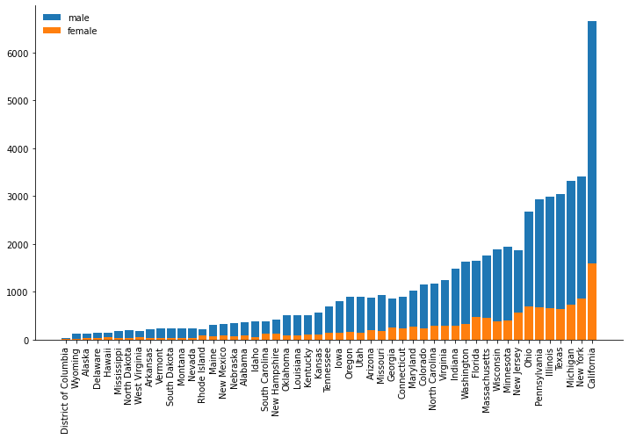

Comparison between regions

From Figure 1, we can also find that the number of inventors varies considerably between regions. Therefore, we have drawn in Figure 2 a map of the number of inventors among different regions in the United States. If we only consider the total number of innovators in each state, California is unsurprisingly the top one, with New York, Michigan, and Texas following. In addition, the central part is relatively less innovative.

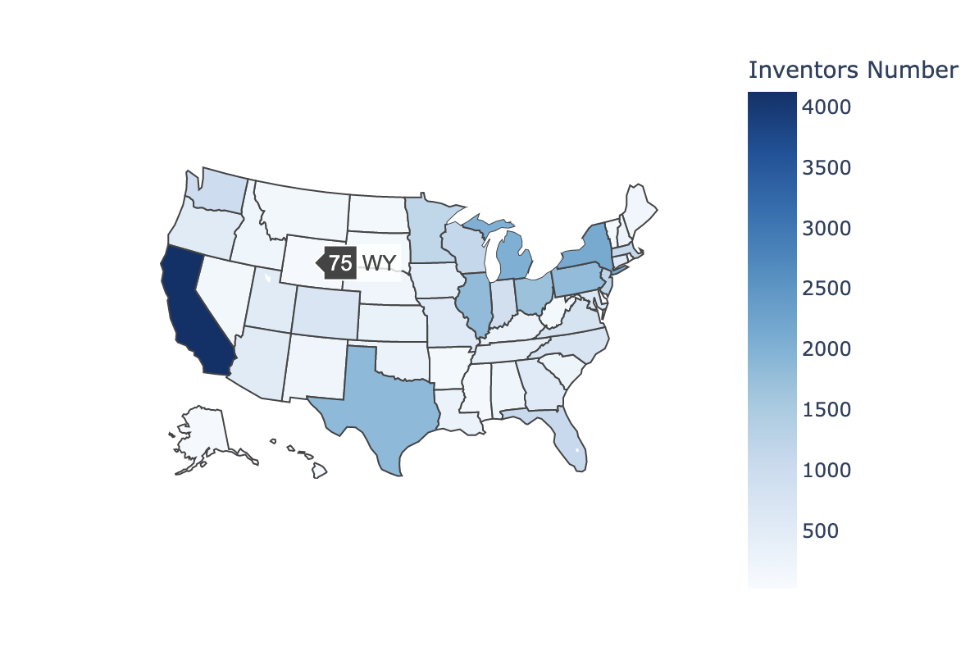

However, this result may be influenced by the population of each state. Therefore, we generalized the population size by finding the number of innovators per 10,000 children and created a map of inventor density. As shown in Figure 3, the northern part of the United States seems to have a higher density of innovators than the southern part. The states with the highest density of innovators are Minnesota, New Hampshire, Massachusetts, and Vermont, which do not coincide with any of the states with the highest total

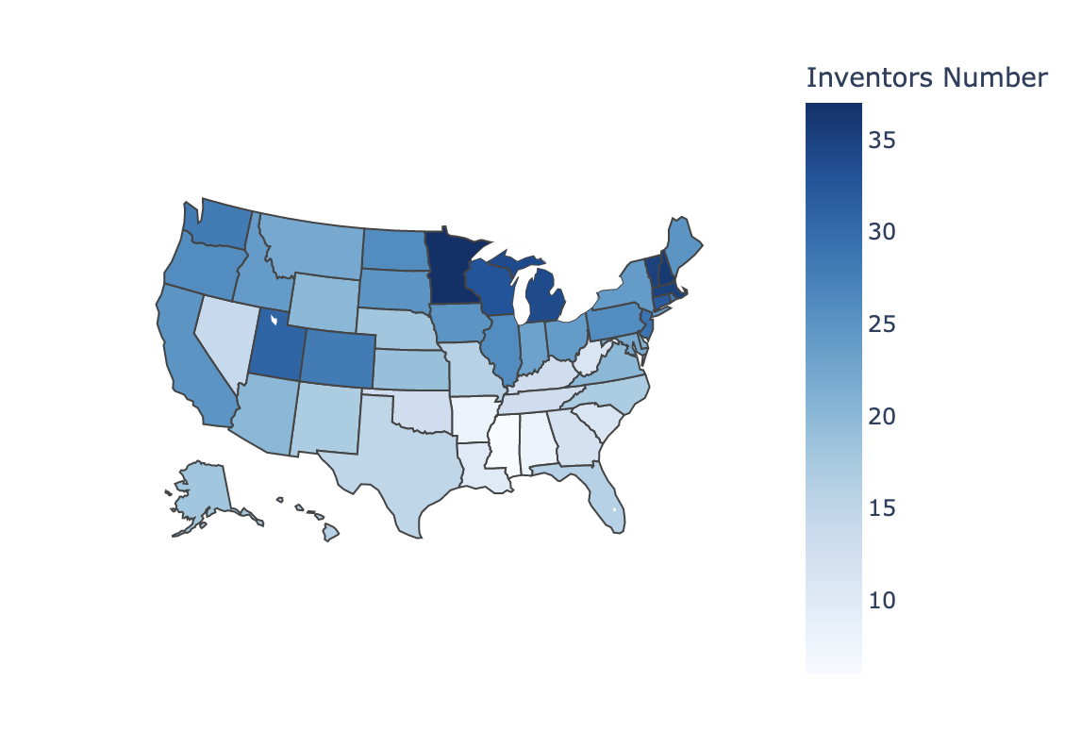

Comparison between socioeconomic status

We categorized parents' socioeconomic status from low to high on a scale of 1 to 5 and compared the proportion of children who became inventors on each scale. We plotted Figure 4 for a random sample of five states from all states (see Appendix A for a comparison of all states). From the graph, we can clearly see that the higher the parents' socioeconomic status, the higher the chance of the children becoming inventors. Moreover, when parents are located in the most elevated status stratum, the proportion of children becoming innovators increases considerably relative to the situation in other strata. This may be due to the fact that parents of higher economic status are more willing to invest more in their children's education, and their children have a relatively more comfortable upbringing to use their imagination and do not need to make a living prematurely.

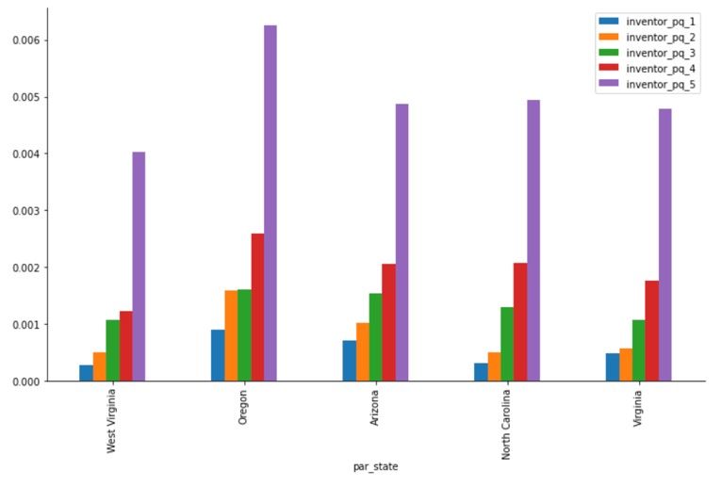

Comparison between college students and population

Based on our dataset, we calculated that the average rate of all students entering university who become inventors is 0.881%, while this value is 0.213% overall. This suggests that students who enter college are more likely to become inventors, although it is possible that only those who are more likely to become inventors enter college. The standard deviation of students entering college to become inventors is 0.0157, while the overall is 0.0008. This indicates that the variability in the probability of becoming an inventor increases after entering university, suggesting that university education plays a role in the development of inventors.

**Conclusions and directions for future research**

[Summarize what you learned. Your summary should touch on each question you asked in your introduction. Briefly discuss follow up research that could improve on your findings.

This section should be relatively short—maybe just a paragraph or two.]

**Appendix A: Figures and tables**

**Figure 1: Comparison of the socioeconomic status of all states**

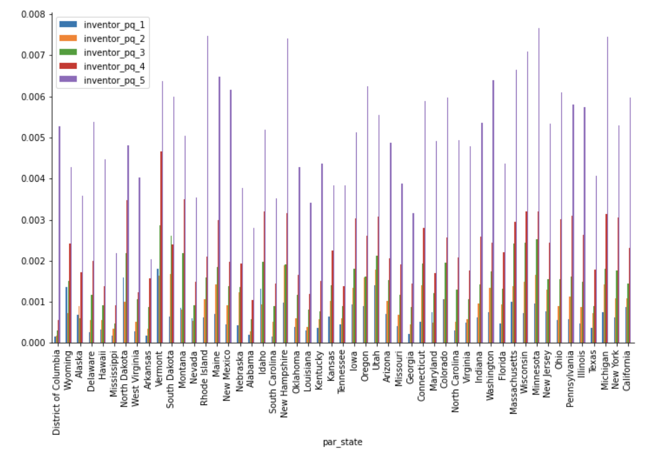

**Appendix B: Variable Description**

|  |  |
| --- | --- |
| **Variable** | **Description** |
| cz | Current commuting zone of residence |
| czname | Commuting zone name |
| state | Current state Federal Information Processing Standard (FIPS) code; CZs that cross state borders are assigned to the state which contains the largest population in the CZ, based on the 2010 Census |
| stateabbrv | Two-letter state abbreviation |
| cohort | Year of birth |
| age | Age at which patenting outcomes are measured |
| year | Calendar year |
| count | Number of individuals in population |
| applicant | Fraction of individuals who apply for a patent in current calendar year |
| grantee | Fraction of individuals who apply for a patent in current year that Is subsequently granted |
| num_grants | Average number of patents grants per individual, by application year |
| grantee_cat_[c] | Fraction of individuals granted a patent in technology category [c], by application year. Technology categories [c] are: 1 – Chemical 2 – Computers and Communications 3 – Drugs and Medical 4 – Electrical and Electronic 5 – Mechanical 6 – Others 7 – Design and Plant |
| [outcome]_g_m | Identical to variable [outcome], but restricting the sample to males. |
| [outcome]_g_f | Identical to variable [outcome], but restricting the sample to females. |
| super_opeid | Institution OPEID / Cluster ID when combining multiple OPEIDs |
| instnm | Name of Institution / Super-OPEID Cluster |
| count | Number of students |
| count_pq_[quintile] | Number of students with parents in quintile [quintile] of the income distribution |
| inventor | Share of inventors among students |
| inventor_pq_[quintile] | Share of inventors among students with parents in quintile [quintile] of the income distribution |
| top5cit | Share of individuals with total patent citations in top 5% of their birth cohort among all inventors matched to a college |
| total_patents | Total number of patents granted to students |
| total_cites | Total number of patent citations obtained by students |